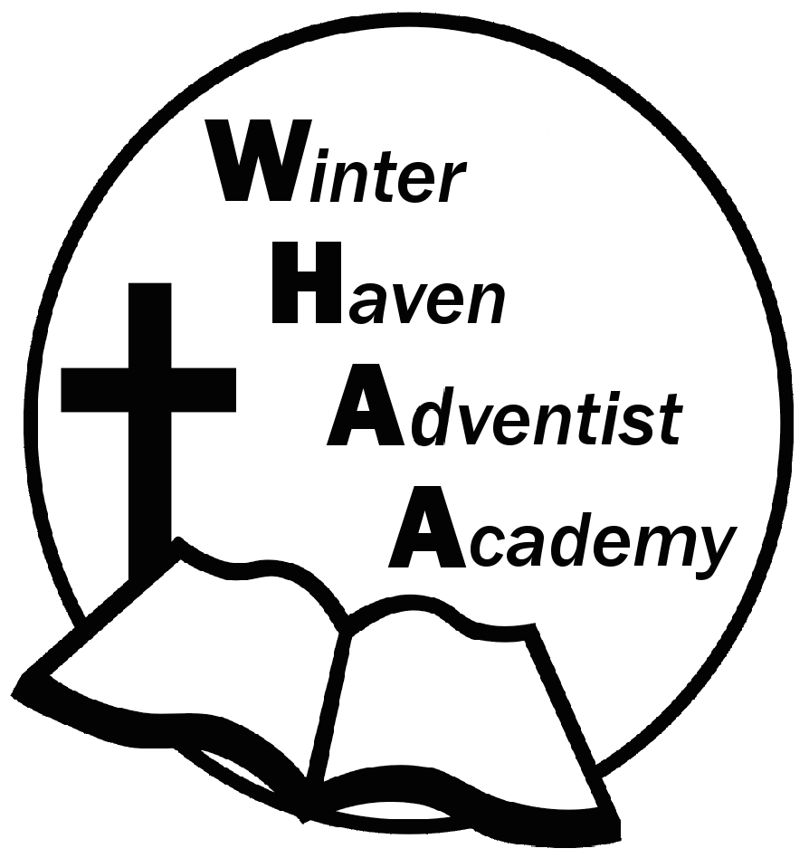
Winter Haven Adventist Academy
Adventist Education

A Journey to Excellence
Week 17 December 11-15, 2023 Newsletter

Dear WHAA Families,
This seventeenth week of the 2023-2024 school has been exciting with the field trip and busy preparing for report cards. Worships this week were brought to us by Mr. Grimm and focused on the theme of Listening and being attentive. WHAA wants to say happy holidays to all families.
Below are some important events to remember.
FRIDAY, DECEMBER 15 SPECIAL DAY: WHAA is reminding parents that a warm breakfast will be provided for the students in the morning. Students will be allowed to dress more casually tomorrow. For example, jeans, a t-shirt, or dress-up that is appropriate will be acceptable for attire. Also, please make sure to arrive on time at 12:00 p.m. tomorrow for dismissal. Thank you for your cooperation. Report cards will be handed out then.
Thank you for your prayers and support. WHAA continues to pray for all the families. Have a blessed and restful winter break!

- Important Dates:
Friday, December 15 Warm Breakfast/Early Dismissal at 12:00 p.m. (Winter Break)
Monday-Friday, December 18-January 1 Winter Break (No School)
Tuesday, January 2 Classes Resume for Third Quarter

Winter Haven Adventist Academy (WHAA)
"Wisdom and Harmony, Anchored in Achievement"

The Wisdom of God, the Harmony of the Holy Spirit, Anchored
in Jesus and Advancing the Achievement Together.

