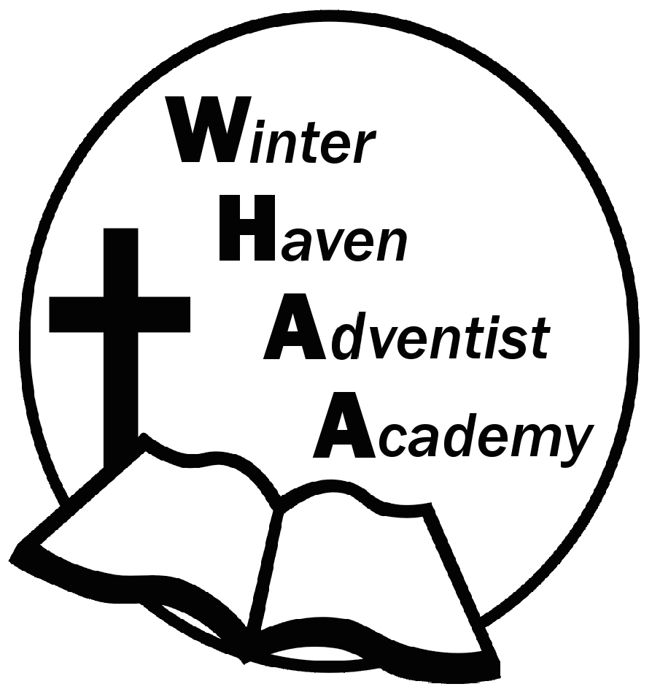
Winter Haven Adventist Academy
Adventist Education

A Journey to Excellence
Week 15 November 27-Dececmber 1, 2023 Newsletter

Dear WHAA Families,
This fifteenth week of the 2023-2024 school has been full of energy after the Thanksgiving holiday. Worships this week were brought to us by Mrs. Turner and focused on the theme of Peace. WHAA hopes that all the families were able to relax during the fall break.
Below are some important events to remember.
ICE FACTORY: WEDNESAY, DECEMBER 13: WHAA wants to remind parents that the next field trip will be ice skating in Kissimmee, Florida. Students will need to dress in warm clothes. Make sure your child/ren have jackets, mittens, a cap, earmuffs, and an extra pair of socks. Students will need to pack a lunch that is non-microwavable. More details about arrival and departure will come soon.
FRIDAY, DECEMBER 15 REPORT CARDS: WHAA wants to inform parents that the second quarter is ending very soon and that the teachers will be handing out report cards on Friday, December 15 during dismissal. No parent-teacher conferences are required for this report card, unless requested by the parent.
FRIDAY, DECEMBER 15 WARM BREAKFAST/EARLY DISMISSAL: WHAA has a special tradition around Winter Break to provide a warm breakfast for the students. Hashbrowns, juice, Morning Star stripples, and pancakes will be available for the students on that morning. Another reminder is that the students will be dismissed at 12:00 p.m. (noon). Please make sure to arrive on time. Thank you for your understanding.
Thank you for your prayers and support. WHAA continues to pray for all the families. Have a blessed and restful weekend!

- Important Dates:
Wednesday, December 13 Ice Factory Kissimmee $20 per child and adult (who plan to go ice skating)
Friday, December 15 Warm Breakfast/Early Dismissal at 12:00 p.m. (Winter Break)
Monday-Friday, December 18-January 1 Winter Break (No School)
Tuesday, January 2 Classes Resume for Third Quarter

Winter Haven Adventist Academy (WHAA)
"Wisdom and Harmony, Anchored in Achievement"

The Wisdom of God, the Harmony of the Holy Spirit, Anchored
in Jesus and Advancing the Achievement Together.

