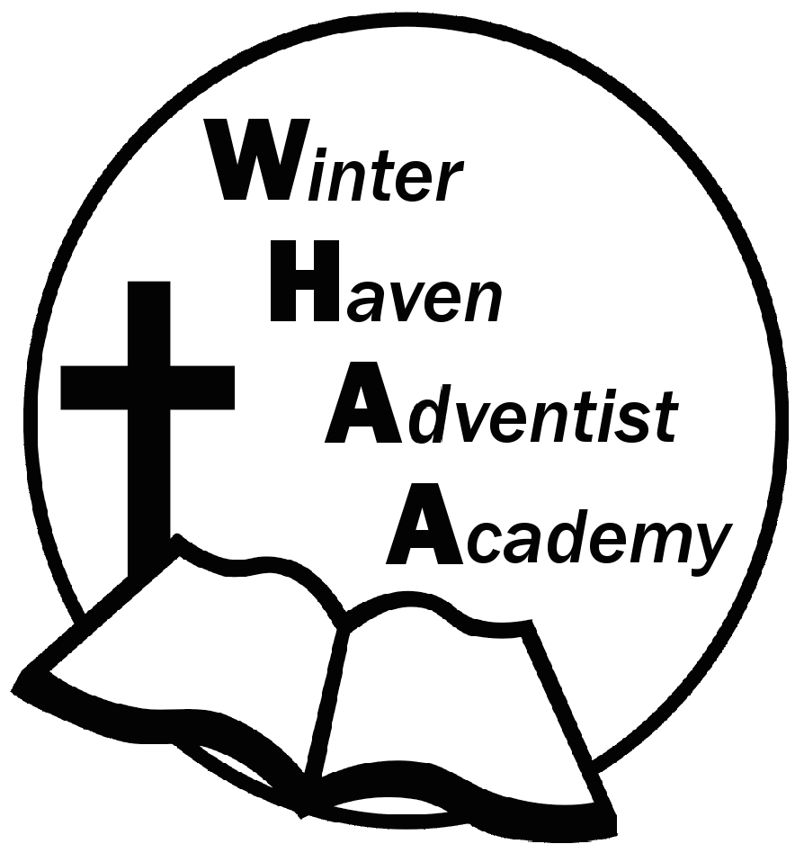
Winter Haven Adventist Academy
Adventist Education

A Journey to Excellence
Week 13 November 6-10, 2023 Newsletter

Dear WHAA Families,
This thirteenth week of the 2023-2024 school year has been busy as the students have been practicing for the church program. Worships this week were put on hold due to maintenance in the church. Thank you to all the WHAA families and their support of Adventist Christian Education.
Below are some important events to remember.
SATURDAY, NOVEMBER 11 FAMILY SABBATH: WHAA wants to remind parents that students need to arrive at the church by 10:30 a.m. and the program will begin at 11:30 a.m. Students can wear regular church attire or the white school shirt with logo and black pants or skirt. Thank you for your understanding. Please join us for fellowship lunch after the program in the school gymnasium. Each family should bring one dish for lunch.
WEDNESDAY, NOVEMBER 15 SEAWORLD FIELD TRIP: WHAA wants to remind parents that students need a packed lunch that does not require the microwave for the trip. The students should wear the lime green school shirt with the logo and jeans. Our current plan is to leave between 8:00-8:30 a.m. and return between 5:30-6:00 p.m. The final head count has been sent to SeaWorld and no additional changes can be made at this time. Thank you for your understanding. This will be an awesome experience for many.
Thank you for your prayers and support. WHAA continues to pray for all the families. Have a blessed and restful weekend!

- Important Dates:
Saturday, November 11 Family Sabbath
Wednesday, November 15 Sea World Orlando $40 per child and adult
Monday-Friday, November 20-24 Fall Break (No School)
Wednesday, December 13 Ice Factory Kissimmee $20 per child and adult (who is ice skating)
Monday-Friday, December 18-January 1 Winter Break (No School)
Tuesday, January 2 Classes Resume for Third Quarter

Winter Haven Adventist Academy (WHAA)
"Wisdom and Harmony, Anchored in Achievement"

The Wisdom of God, the Harmony of the Holy Spirit, Anchored
in Jesus and Advancing the Achievement Together.

