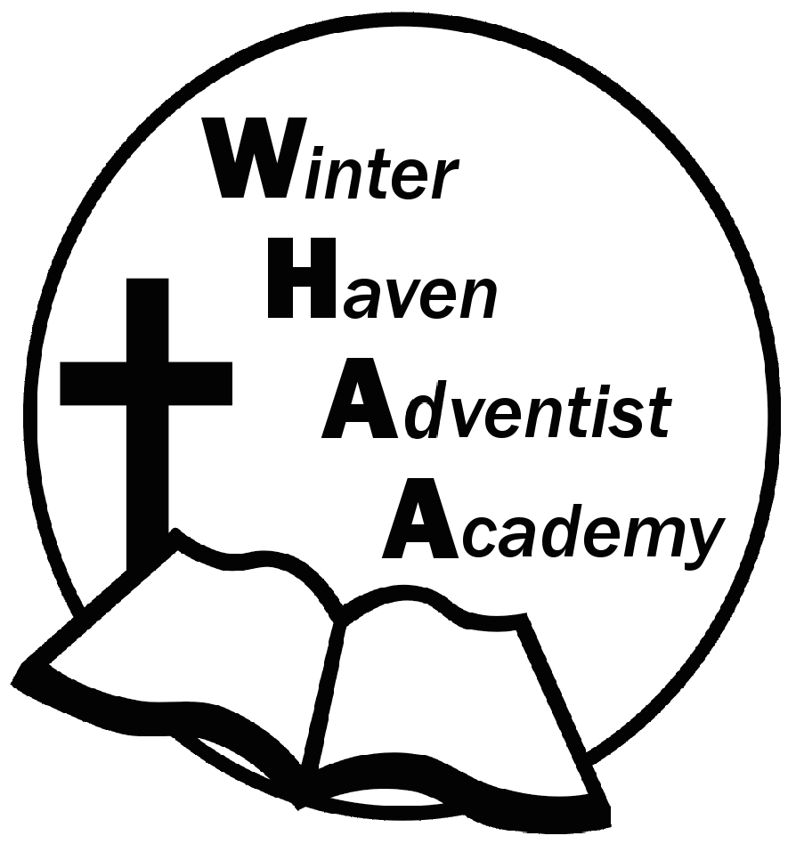
Winter Haven Adventist Academy
Adventist Education

A Journey to Excellence
Week 6 September 18-22, 2023 Newsletter

Dear WHAA Families,
This sixth week of the 2023-2024 school year has been an interesting week with students and staff getting sick or not feeling well. WHAA is praying everyone can stay healthy during this time. Worships this week were brought from Mrs. Turner and focused on the topic of compassion. WHAA wants to thank all the families for their support of Adventist Education.
Below are some important events to remember.
SATURDAY, SEPTEMBER 30 FAMILY SABBATH: WHAA has a full day planned for the families and students on Saturday, September 30. WHAA will be having a church program, followed by a fellowship dinner in the school gymnasium, then the school plans to have a family outing in the afternoon. The family day will continue with an evening vesper at the church, followed by a PIE (Parents Involved in Education) meeting in the school gymnasium. This PIE meeting will involve fun activities for all ages. We look forward to a great day together.
FIELD TRIP LINK: Mr. Grimm has created a way for parents to plan for school field trips in advance. This helps WHAA to be able to know how many students and adults will be attending each of these field trips. Attached to this newsletter is the link.
Link for Field Trips: https://forms.gle/tbhrLHpSggjdSUMy8
Thank you for your prayers and support. WHAA continues to pray for all the families. Have a blessed and restful weekend!

- Important Dates:
Saturday, September 30 Family Sabbath (Students have program, fellowship dinner, family outing, vespers, followed by Pie Meeting)
Saturday, September 30 Adventurer Registration from 2-4 p.m. (Sandi Duerr 863-662-2495) (Please text her and she will get back with you in case you are interested.
Field Trip, October 4, MOSI - Tampa

Winter Haven Adventist Academy (WHAA)
"Wisdom and Harmony, Anchored in Achievement"

The Wisdom of God, the Harmony of the Holy Spirit, Anchored
in Jesus and Advancing the Achievement Together.

